Christmas Co Parenting Plan

Parent 1 please fill out section below:
Day that Child/ren will celebrate Christmas with Parent 1:
Date: ______________ Start time: _____________ Children will be transported to: _______________ by: _________________
Finish Date: _______________ Transition Time: ___________________ Children will be transported to: _______________ by: _________________
Main Presents that they will receive at my house from me are:
__________________________________________________________________________
I would/would not like Santa to come to my house (please circle one) If Santa is coming, we have asked him to deliver:

I would like children to keep presents they receive at my house at my house
Yes/I’m not bothered (Please circle one)
I am ok/not ok for you to call/facetime the children. Call time:__________

Additional Requests (Can include bedtimes, naps, food related)
Please state all requests in a respectful manner and understand that each parent has the choice to parent as they see fit on their time. Please also take your co-parents requests to heart.
____________________________________________________________________________________________________________________________________________________________

Parent 2 fill out section below:
Day that Child/ren will celebrate Christmas with Parent 2:
Date: ______________ Start time: _____________ Children will be transported to: _______________ by: _________________ Finish Date: _______________ Transition Time: ___________________ Children will be transported to: _______________ by: _________________

Main Presents that they will receive at my house from me are:
__________________________________________________________________________
I would/would not like Santa to come to my house (please circle one) If Santa is coming, we have asked him to deliver:

I would like children to keep presents they receive at my house at my house
Yes/I’m not bothered (Please circle one)

I am ok/not ok for you to call/facetime the children. Call time:__________

Additional Requests (Can include bedtimes, naps, food related)
Please state all requests in a respectful manner and understand that each parent has the choice to parent as they see fit on their time. Please also take your co-parents requests to heart.
____________________________________________________________________________________________________________________________________________________________

Points to remember over the holidays
- Keep transitions brief and non-confrontational. If this is not possible, enlist the help of a third party to facilitate the transitions
- It’s not a competition. Working together to ensure that there is a balance of presents at both homes is in the children’s best interest.
- Speak well of each other to your children. Try to shield your children from your sadness. It is a big responsibility for little people to feel guilty that someone they love is lonely or sad.
- Communication and clarity is key. Make sure that ALL the details are agreed upon in advance and once agreed, communicate the plan with children so they can feel secure.
- Remember that these beautiful children came from both of you.

I agree to the above terms set out in my co-parent’s section and will do my best to maintain this agreement and to put the children first. Pledge: I agree to put aside our differences over the holidays and to put the children first. I agree to be amicable and to work together so that our child/ren have the best possible holiday season.

Mother Signature: _______________________ Date: _____________

Father Signature: _______________________ Date: _____________
THIS IS NOT A LEGALLY BINDING DOCUMENT, nor takes the place of a formal parenting agreement. It is intended to help families to have a clear plan over the holidays to create the smoothest experience possible for the children.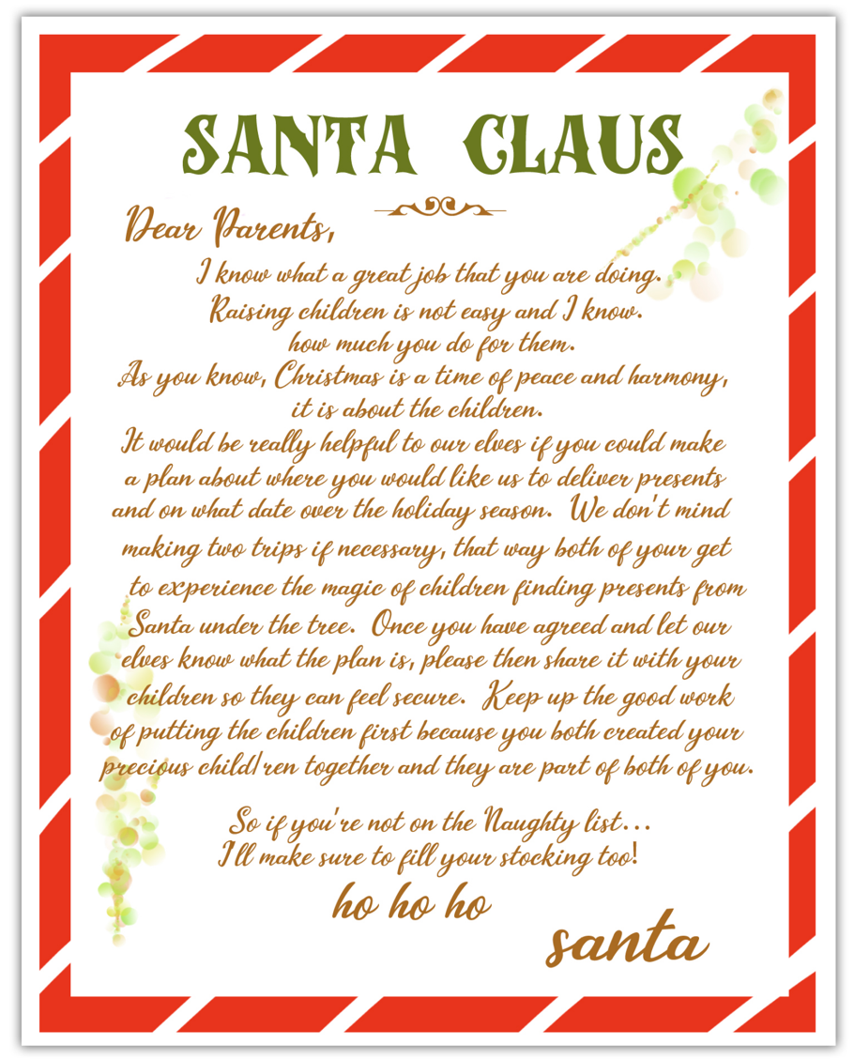
*An excerpt from "How will Santa find me?" A book for children with two homes by: Carin Smolinski

